# Department of Computing

**CS 354: Compiler Construction**

**Class:** BSCS-8AB

# Lab [06]: Basic Syntax Analysis using Bison

**Date:** 5th Nov, 2021

# Time: Friday (10:00 – 1:00 & 02:00 - 5:00)

# Instructor: Dr Syed Atif Ali Shah

# Lab Instructor: M . Danyal Sadiq

# Lab [06]: Basic Syntax Analysis using Bison

**Introduction**

The syntactic or the structural correctness of a program is checked in the syntax analysis phase of compilation. The structural properties of language constructs can be specified in different ways. Different styles of specifications are useful for different purposes.

**Objectives**

1. Successful understanding/implementation of Syntax Analysis

**Tools/Software Requirement**

1. Flex & Bison on Linux or Windows platform

**Description**

Syntax analysis or parsing, is needed to determine if the series of tokens given are appropriate in a language - that is, whether or not the sentence has the right shape/form. However, not all syntactically valid sentences are meaningful, further semantic analysis has to be applied for this purpose. For syntax analysis, context-free grammars and the associated parsing techniques are powerful enough to be used - this overall process is called parsing.

In syntax analysis, parse trees are used to show the structure of the sentence, but they often contain redundant information due to implicit definitions (e.g., an assignment always has an assignment operator in it, so we can imply that), so syntax trees, which are compact representations are used instead. Trees are recursive structures, which complement CFGs nicely, as these are also recursive (unlike regular expressions).

There are many techniques for parsing algorithms (vs FSA-centred lexical analysis), and the two main classes of algorithm are top-down and bottom-up parsing.

Context-free grammars can be represented using Backus-Naur Form (BNF). BNF uses three classes of symbols: non-terminal symbols (phrases) enclosed by brackets <>, terminal symbols (tokens) that stand for themselves, and the meta-symbol **::=** *- is defined to be.*

As derivations are ambiguous, a more abstract structure is needed. Parse trees generalize derivations and provide structural information needed by the later stages of compilation.

**Parse Trees**

Parse trees over a grammar G is a labeled tree with a root node labeled with the start symbol (S), and then internal nodes labeled with non-terminals. Leaf nodes are labeled with terminals or ε. If an internal node is labeled with a non-terminal A, and has n children with labels X1, ..., Xn (terminals or non-terminals), then we can say that there is a grammar rule of the form A → X1...Xn. Parse trees also have optional node numbers.

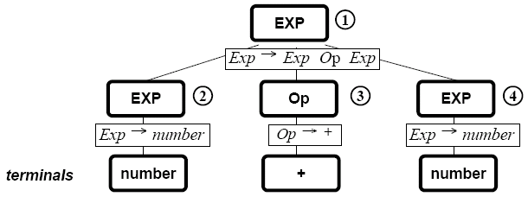

The above parse tree corresponds to a leftmost derivation.

Traversing the tree can be done by three different forms of traversal. In pre-order traversal, you visit the root and then do a pre-order traversal of each of the children, in in-order traversal, an in-order traversal is done of the left sub-tree, the root is visited, and then an in-order traversal is done of the remaining sub-trees. Finally, with post-order traversal, a post-order traversal is done for each of the children and the root is visited.

**Syntax Trees**

Parse trees are often converted into a simplified form known as syntax tree that eliminates un-necessary information from the parse tree.

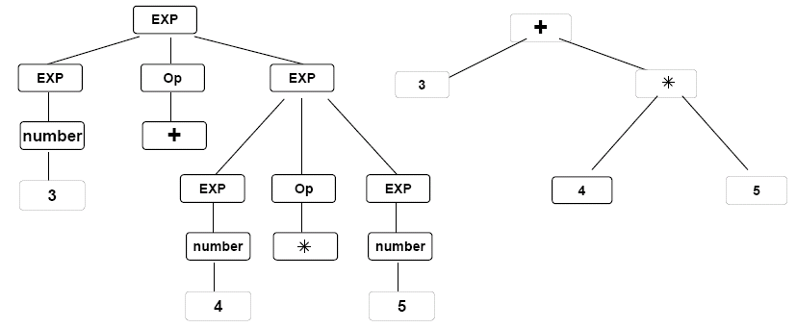

**Lab Tasks**

* **Introduction to bison**: Study the bison tutorial provided on LMS.
* Try the simple calculator example that recognizes and evaluates binary postfix expressions using a stack e.g. **4 8 +**
* You are required to make a prefix i.e. **+ 4 8** and infix i.e. **4 + 8** versions of the calculator.

You can use the following compilation steps for generating parser using flex & bison:

|  |
| --- |
| bison –d postfix.y (will produce postfix.tab.c and postfix.tab.h)  gcc –c postfix.tab.c (will produce postfix.tab.o)  flex calc.l (will produce lex.yy.c)  gcc –c lex.yy.c (will produce lex.yy.o)  gcc –o PARSER lex.yy.o postfix.tab.o –lfl –ly (will produce PARSER)  Running the parser:  ./PARSER |

**Deliverables**

You are required to upload your task (Sources & PDF document) using the link created on LMS, may be followed by a viva.